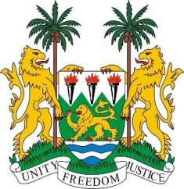
SIERRA LEONE

27th Session of the UPR

POLAND

9 May 2017
Mr President,

Sierra Leone welcomes the distinguished delegation from Poland to this third review cycle and thanks them for their presentation.

My delegation notes the impressive progress made and commends Poland for updating its national legislation as regards better promoting and protecting the rights of migrants and criminalising the trafficking in persons -as evidenced in its updated Criminal Code and the National Action Plan against Trafficking.

Furthermore, we note that the government has issued a standing invitation to all UN special procedures mandate holders since 2001 and that Poland has also consistently contributed to the OHCHR since 2012.

My delegation encourages Poland to make greater efforts to address the economic and social rights of the minority Roma peoples in areas such as access to housing, medical care, education and employment as well as to ensure respect of the principle of non-refoulement of asylum seekers.

Recommendations:

1. Ratify the ICPPED and integrate it into national norms.
2. Amend the Criminal Code to clearly criminalize domestic violence and implement a comprehensive strategy to eliminate all forms of violence against women.
3. Reinstate the Council for the Prevention of, Xenophobia and Related Intolerance or create an alternative multi-stakeholder institution with the objective of preventing discrimination and intolerance, in all its aspects.
4. Consider increasing its level of Overseas Development Assistance (ODA).

Finally, Sierra Leone wishes Poland every success in implementing the accepted recommendations.

Thank you, Mr President.

